Recipe for Success Foundation Challenges America to Eat Your Veggies!
The New VegOut! App Makes Eating 30 Veggies in 30 Days a Fun, Food Adventure
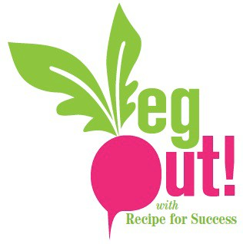
January 1, 2016. HOUSTON, Texas. Recipe for Success Foundation’s 2016 VegOut! Challenge 30 ways in 30 Days is making eating veggies a deliciously healthy, fun food adventure with their brand new, free and easy-to-use mobile App and revitalized VegOutWithRFS.Org website. Track your veg, find recipes and challenge friends, family and coworkers through the mobile App and sleek website that make “Vegging” out easy peasy!

Apps are proliferating the health and wellness space, and studies, like the recent Make Better Choices 2 trial, have found that when combined with the proper coaching, they showed significant improvement in diet and an increase in the intake of fruit and vegetables. Only 6% of Americans eat their recommended target for vegetables while the USDA leads the call for more veggies on the plate. Adding variety to your plate will help keep you excited about your food intake.

Have you ever tried daikon or bok choy? Do you know the origins of kohlrabi? Recipe for Success Foundation’s focuses on changing the way we eat by making healthy eating a fun adventure, and VegOut! is more accessible than ever with the launch of the new mobile App that allows you to track your veg, interact with your group and access free recipes with just a click of button. Created in partnership with Pariveda Solutions, the app puts the power of vegetables directly at your fingertips. Pariveda selected Recipe for Success as their partner non-profit for 2015, and deployed a pro-bono team that worked feverishly through the summer and fall to get the VegOut! App ready in time for this year’s Challenge!

Participants will be able to easily sign up, form teams and find veggie inspiration- from recipes to nearby purveyors of fresh produce directly from their smart phone. Recipe for Success is encouraging participants to pass the Challenge forward and challenge other teams, restaurants, companies, schools, churches and more to VegOut!

Consuming more fresh produce is one of the simplest ways to jumpstart healthier habits, plus trying new foods is fun. During the VegOut! Challenge, Recipe for Success makes it even more fun with events, games, prizes and a virtual potluck to keep you on the turnip truck for all 30 days.
For more information, visit VegOutwithRFS.org and download the VegOut! Mobile app to register, track your progress, and find great recipes and resources. Keep up with the VegOut! Challenge on social media, by using the hash tag #VegOutRFS to see who is vegging out this March.
###
About Recipe For Success
Celebrating its tenth anniversary year, Recipe for Success Foundation is a non-profit 501C3 that focuses on combating childhood obesity by changing the way our children understand, appreciate and eat their food and by educating and mobilizing the community to provide healthier diets for children, with programs that have empowered more than 30,000 children in Houston and beyond with the knowledge and skills they need to lead healthier lives. The Foundation works to create a culture where nutritious food is shared, appreciated, and celebrated. Through its award-winning efforts like the nationally-offered Seed-to-Plate Nutrition Education™ in schools, Eat It! Food Adventures children's cookbooks, farmers marKIDS DAYS and the VegOut! 30-Day Challenge, and the Hope Farms urban agriculture project in Houston, the Foundation works to make healthy food appealing and available to everyone. For more information call 713-520-0443 or see www.recipe4success.org

